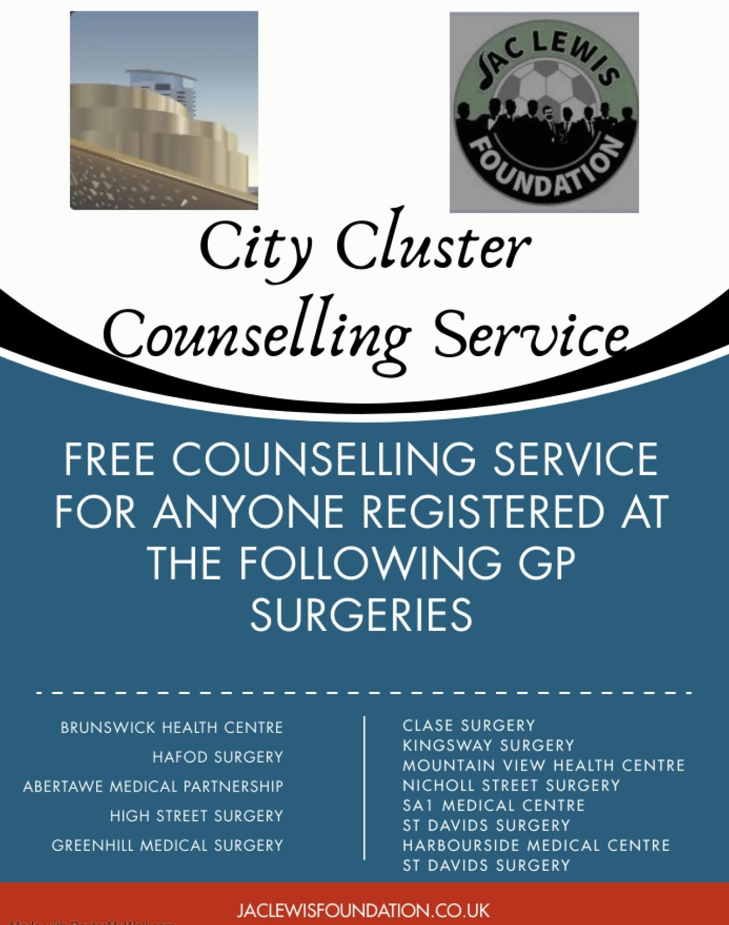

Free face-to-face or virtual counselling sessions now available for our patients:
Referral Form – Jac Lewis Foundation
Please follow link to complete a self-referral form

